*HARSH KASHYAP  
CSE 4*

*101917088*

[*hkashyap_be19@thapar.edu*](mailto:hkashyap_be19@thapar.edu)

A Practical activity Report submitted

for Practical Computing (UCS311)

**PRACTICAL COMPUTING**



Computer Science and Engineering

Patiala Campus

**2020**

Submitted to

Aashima Sharma

**__________________________________________**

**Assignment 1**

**Question 1**

**A) List out all the files present in the system (including hidden ones)**

**B) list all the files with their size**

**C) sort all the listed files with time and date.**

**Solution - a) ls -a**



**b) ls -al in long format**

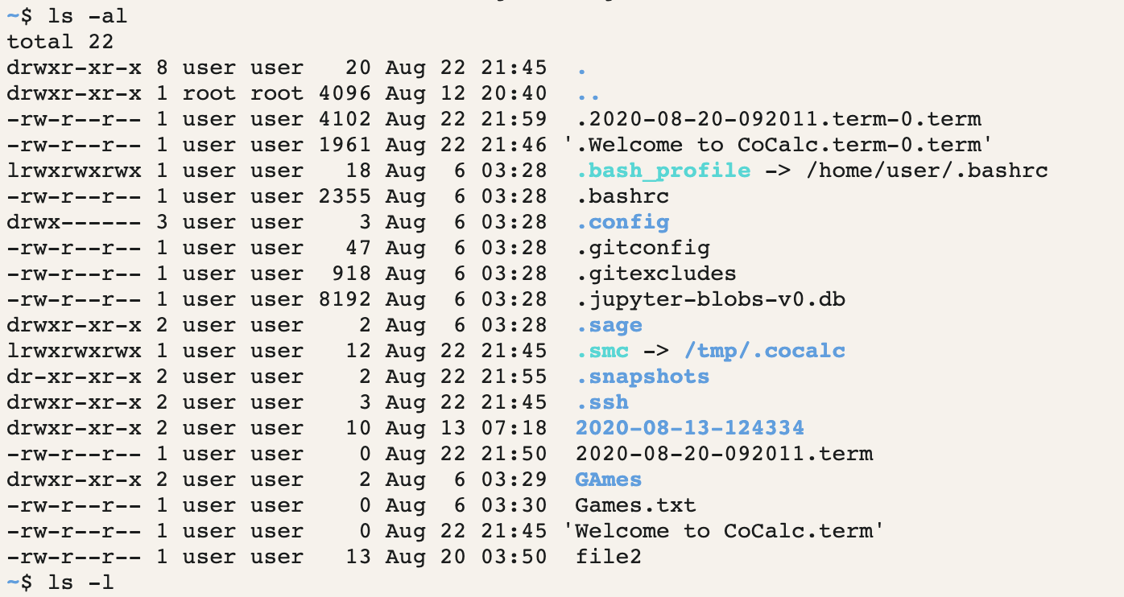

**c) ls -alt**

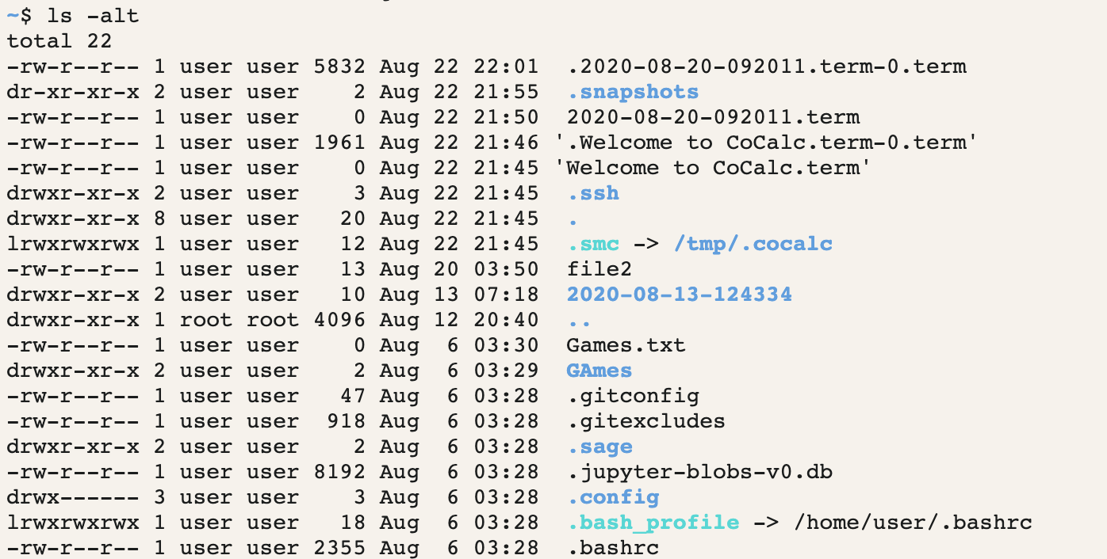

**__________________________________________**

**Question 2**

**We have a file sample.txt.**

**A) How can we use this redirection operator as “>”?**

**B) Also, the other redirection operator as “>>”**

**Solution**

**The “>” operator is used to write on a file and if certain contents are already present it will automatically overwrite the contents of the file.**

**Whereas, the “>>” operator is used to append contents to the existing file.**

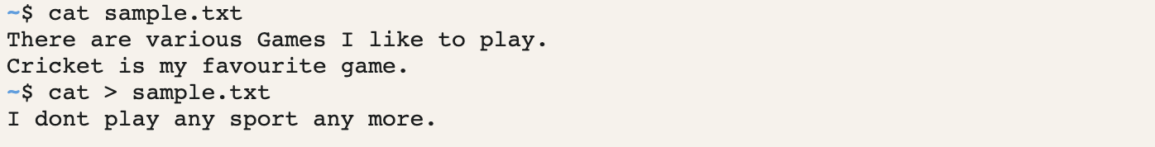

**__________________________________________**

**Question 3**

**How to copy a file in Linux?**

**Solution**

**To copy a file in Linux, we use cp command.**

**Syntax - cp SourceFile TargetFile**

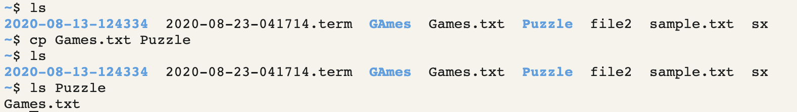

**__________________________________________**

**Question 4**

**How would you delete a directory in Linux? Execute both the commands.**

**Solution - rmdir**

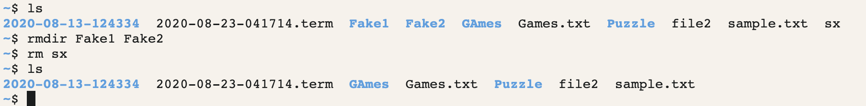

**__________________________________________**

**Question 5**

**How does the case sensitivity effects the way you use commands?**

**Solution - Linux is case sensitive. The commands that are running in lowercase won’t run in uppercase.**



**__________________________________________**

**Question 6**

**A) How can we switch from present directory to any other directory?**

**B) Create one directory with the name practical computing.**

**C) Create a file in practical computing directory with the name as commands.txt.**

**D) Write the basic commands in that particular file**

**E) Copy the content of commands.txt to linuxcommands.txt**

**F) Check if the contents have been written on the new file**

**G) Remove the previous file i.e. commands.txt from the directory itself**

**Solution -**

**A) To switch from parent to any other directory, use command cd followed by the directory you want to switch.**

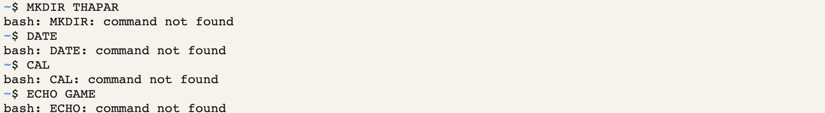

**The next commands as follows :**

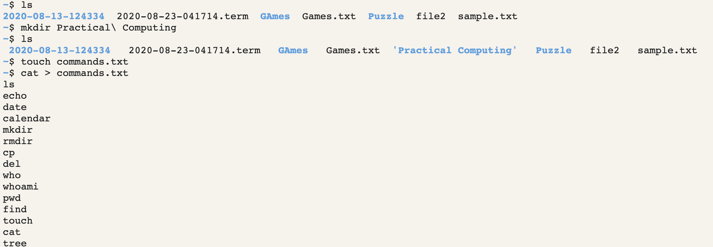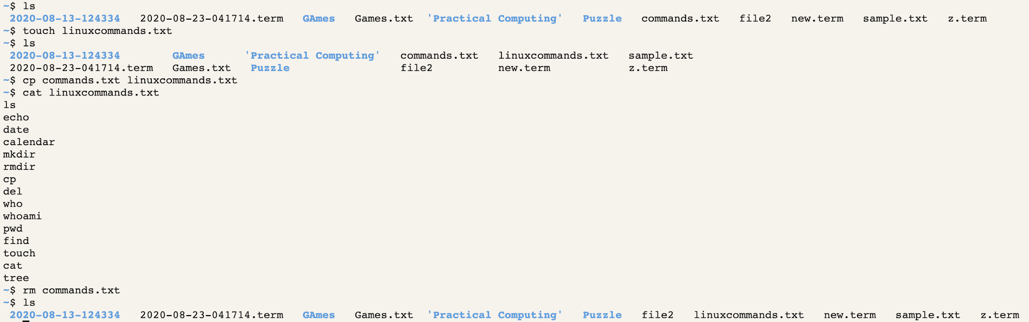

**__________________________________________**

**__________________________________________**

**Assignment 2**

**Question 1**

**What command is used on Linux to change the group of a file or directory?**

**Solution -**

In Linux, each file is associated with an owner and a group and has permissions that determine which users may read, write, or execute the file. Unlike the chown command that allows you to change the user and group ownership, chgrp changes only the group ownership. To find out to which group the file belongs to, use the ls -l command. Regular users can change the group of the file only if they own the file and only to a group of which they are a member. Administrative users can change the group ownership of all files.

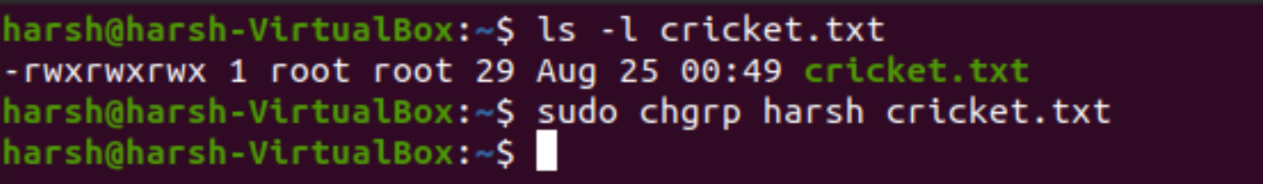

**__________________________________________**

**Question 2**

**Make sure you have all the rights to the files, and others can only read.**

**Solution**

We can have all write for ourselves by giving read write and execute permissions for ourselves and giving the others only read permission.

We can give us 7 read-write and execute and groups and others 4 so that they can only read.

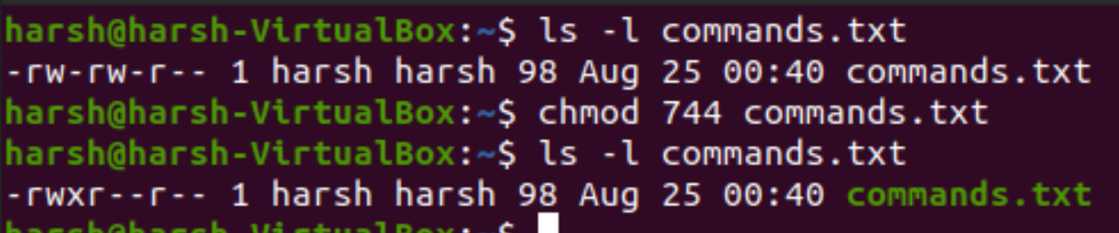

**__________________________________________**

**Question 3**

**With chmod, is 770 the same as rwxrwx---?**

**Solution**

**Yes, they both are same.**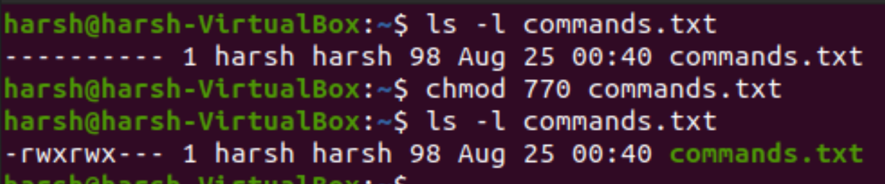

**__________________________________________**

**Question 4**

**With chmod, is 400 the same as r--------?**

**Solution -**

Yes, both are same.

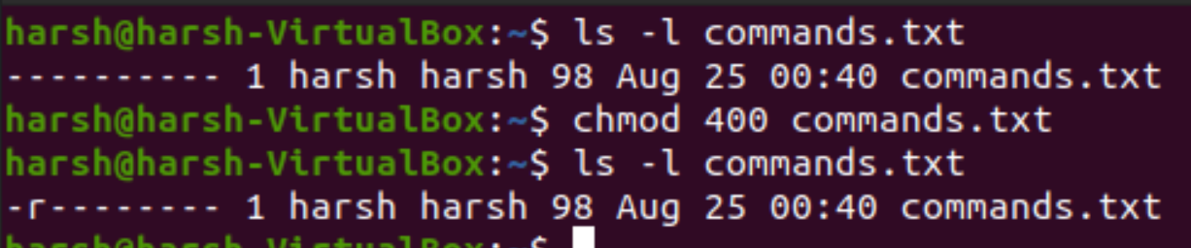

**__________________________________________**

**Question 5**

**Q5. With chmod, is 734 the same as rwxr-xr--?**

**Solution -**

No, they are different.

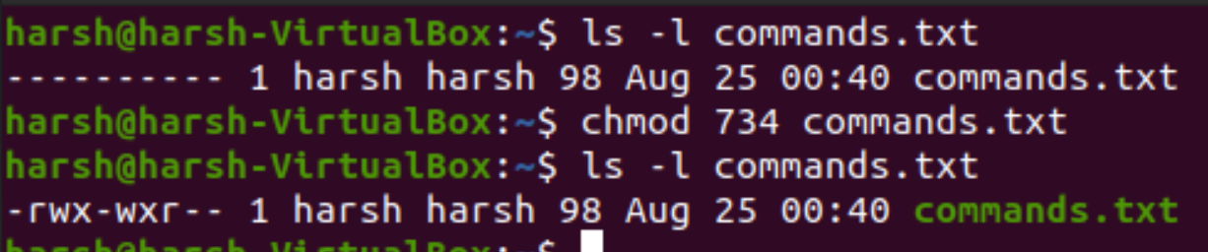

**__________________________________________**

**Question 6**

**Create a file as root, give only read to others.**

**Solution -**

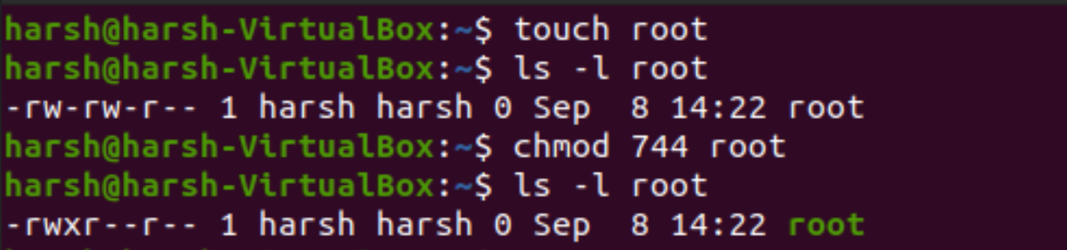

**__________________________________________**

**Question 7**

**Create a directory that belongs to a group, where every member of that group can read and**

**write to the files and create files. Make sure that people can only delete their own files.**

**Solution -**

The restricted deletion flag or sticky bit is a single bit, whose interpretation depends on the file type. For directories, it prevents unprivileged users from removing or renaming a file in the directory unless they own the file or the directory; this is called the restricted deletion flag for the directory, and is commonly found on world-writable directories like /tmp.

So, to make sure that people can create and delete files but can delete their own files only, we will add 1 in chmod.

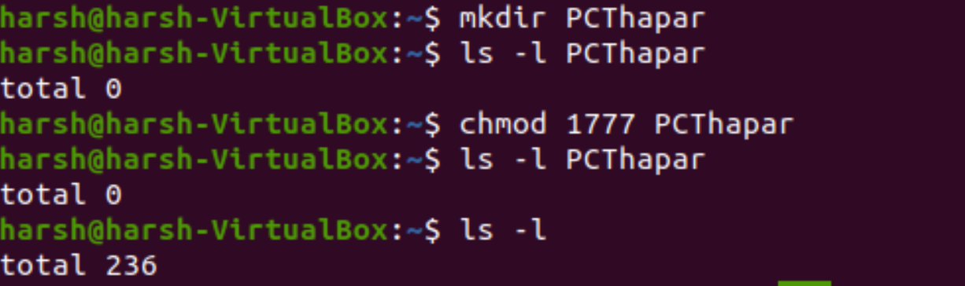



**__________________________________________**

**Question 8**

**Allow read permissions to everyone.**

**Solution -**

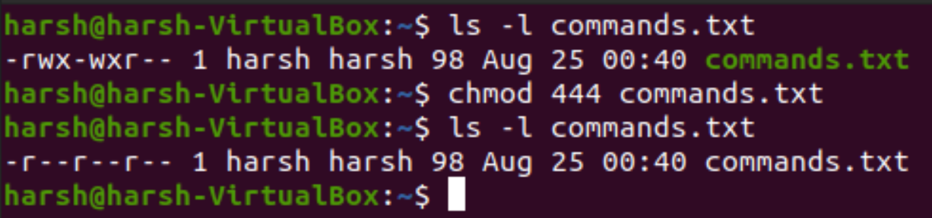

**__________________________________________**

**Question 9**

**Allow everyone to read, write and execute the files.**

**Solution -**

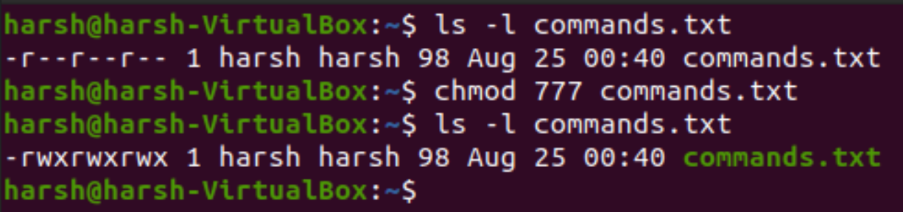

**__________________________________________**

**Question 10**

**Deny execute permission from everyone.**

**Solution -**

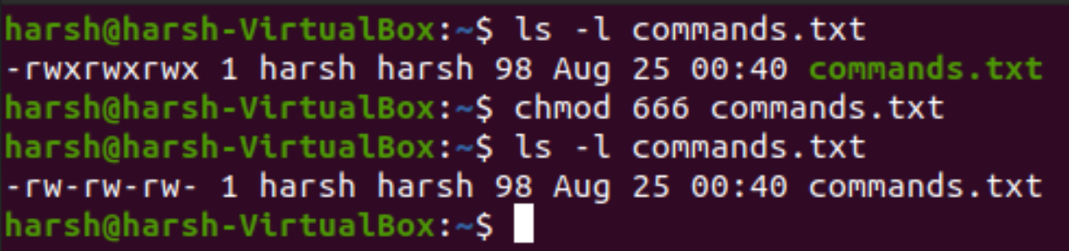

**__________________________________________**

**Question 11**

**Write permissions will the following command give: chmod 641?**

**Solution -**

This will give read and write permission to the owner, read permission to the group and execute permission to others.

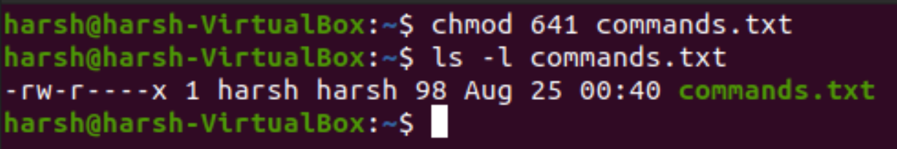

**__________________________________________**

**Question 12**

**Copy a file owned by root from /etc/ to your permissions dir, who owns this file now.**

**Solution -**

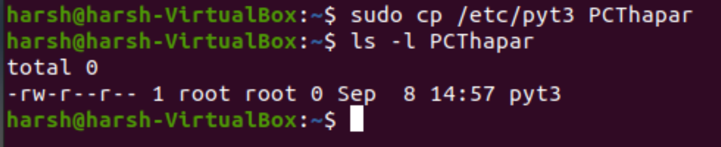

**__________________________________________**

**_________________________________________**

**Assignment 3**

**Question 1**

**How can we pass arguments to a script in Linux? And how to access these arguments**

**from within the script?**

**Solution -**

Arguments can be passed to the script when it is executed, by writing them as a space-delimited list following the script file name. Inside the script, the $1 variable references the first argument in the command line, $2 the second argument and so forth. The variable $0 references to the current script.

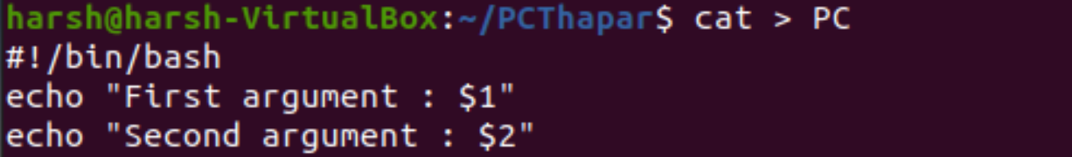

To access the elements, write the argument while you are going to run the script.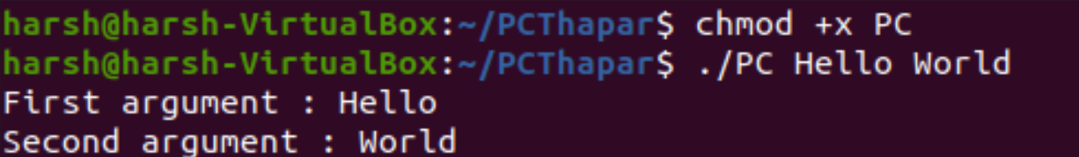

**__________________________________________**

**Question 2**

**Write a shell script to get the current date, time, username and current working directory.**

**Solution**

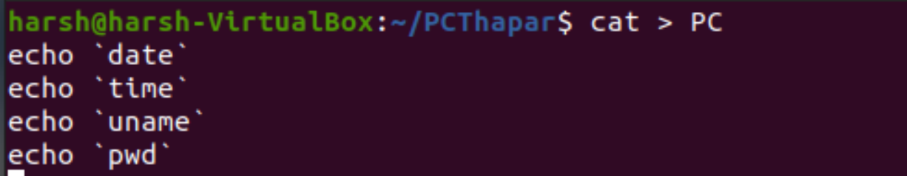

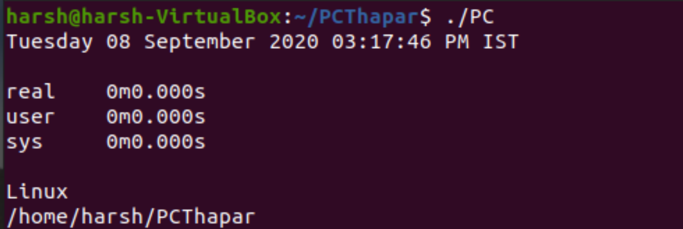

**__________________________________________**

**Question 3**

**How to ask for input in a shell script from the terminal?**

**Solution**

**To ask for input , we can prompt user simply and then read the input given by the user.**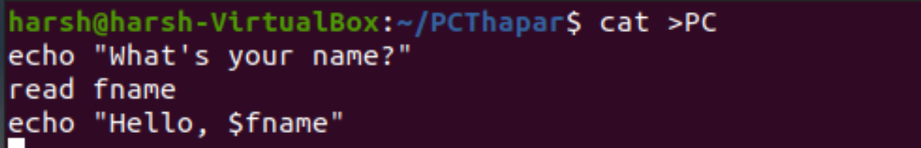

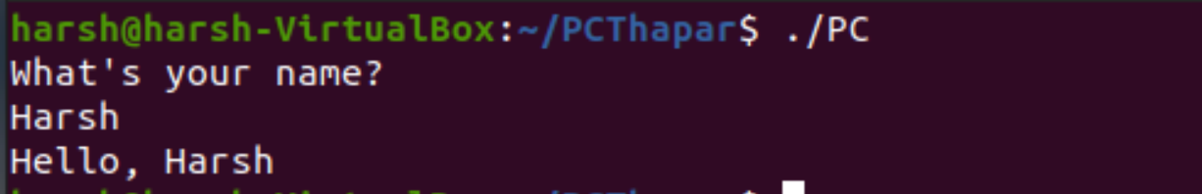

**__________________________________________**

**Question 4**

**How can we perform numeric comparisons in Linux?**

**Solution -**

Performing comparisons is done as follows.

This is one the most common evaluation method i.e. comparing two or more numbers. We will now create a script for doing a numeric comparison, but before we do that we need to know the parameters that are used to compare numerical values .

Below mentioned is the list of parameters used for numeric comparisons

* num1 -eq num2 check if 1st number is equal to 2nd number
* num1 -ge num2 checks if 1st number is greater than or equal to 2nd number
* num1 -gt num2 checks if 1st number is greater than 2nd number
* num1 -le num2 checks if 1st number is less than or equal to 2nd number
* num1 -lt num2 checks if 1st number is less than 2nd number
* num1 -ne num2 checks if 1st number is not equal to 2nd number

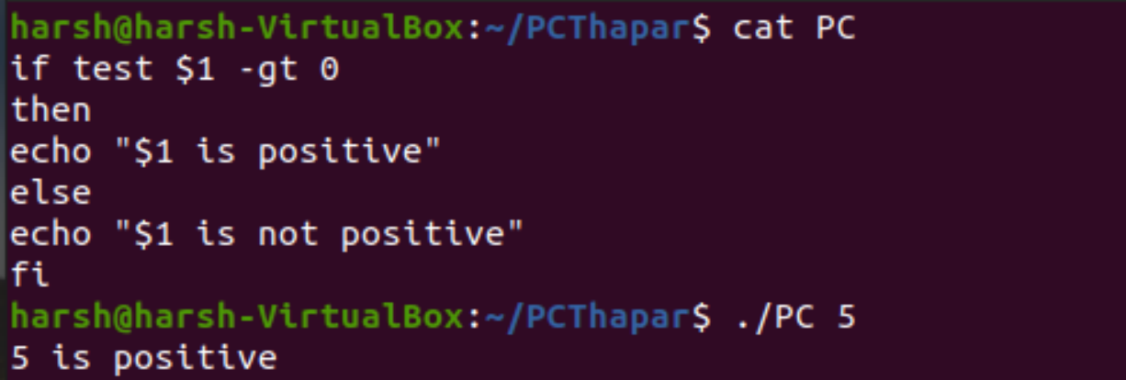

**__________________________________________**

**Question 5**

**Q5. What is the syntax for different types of loops available in shell scripting?**

**Solution -**

Looping Statements in Shell Scripting: There are a total of 3 looping statements which can be used in bash programming while statement, for statement, until statement

Their descriptions and syntax are as follows:

**while statement:**

Here the command is evaluated and based on the result loop will executed, if command raise to false then loop will be terminated

**Syntax**

while command

do

Statement to be executed

done

**for statement**.

The for loop operate on lists of items. It repeats a set of commands for every item in a list. Here var is the name of a variable and word1 to wordN are sequences of characters separated by spaces (words). Each time the for loop executes, the value of the variable var is set to the next word in the list of words, word1 to wordN.

**Syntax**

for var in word1 word2 ...wordn

do

Statement to be executed

done

**until loop**

The until loop is executed as many as times the condition/command evaluates to false. The loop terminates when the condition/command becomes true.

**Syntax**

until command

do

Statement to be executed until command is true

done

**__________________________________________**

**Question 6**

**How will you find the sum of all numbers in a file in Linux?**

**Solution -**

**Create a text file which contains integers.**

**Then in other file perform the following operations.**

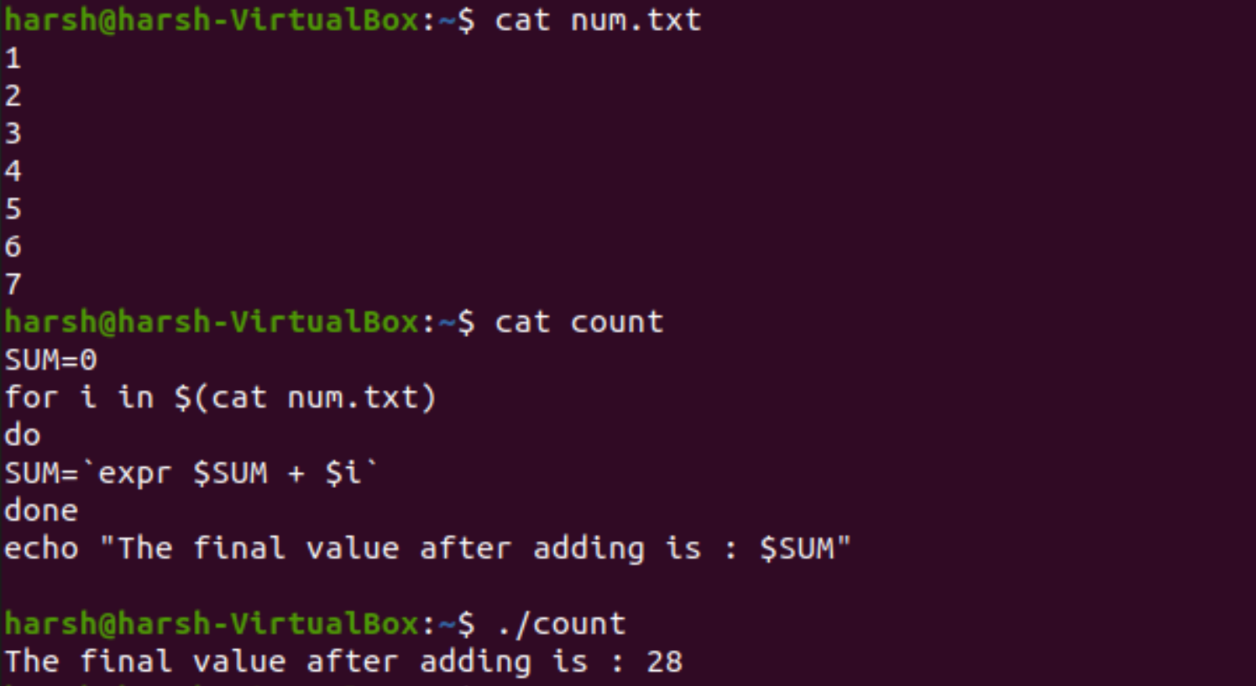

**__________________________________________**

**Question 7**

**Write a shell script to validate password strength. Here are a few assumptions for the**

**password string.**

**• Length – a minimum of 8 characters.**

**• Contain both alphabet and number.**

**• Include both the small and capital case letters.**

**Solution -**

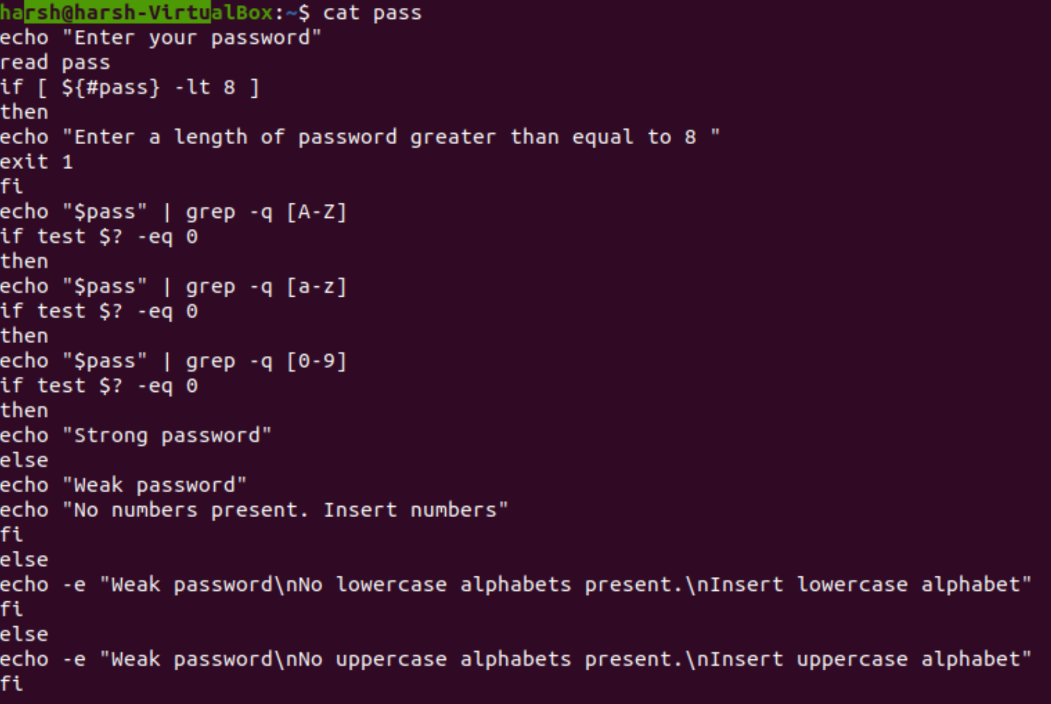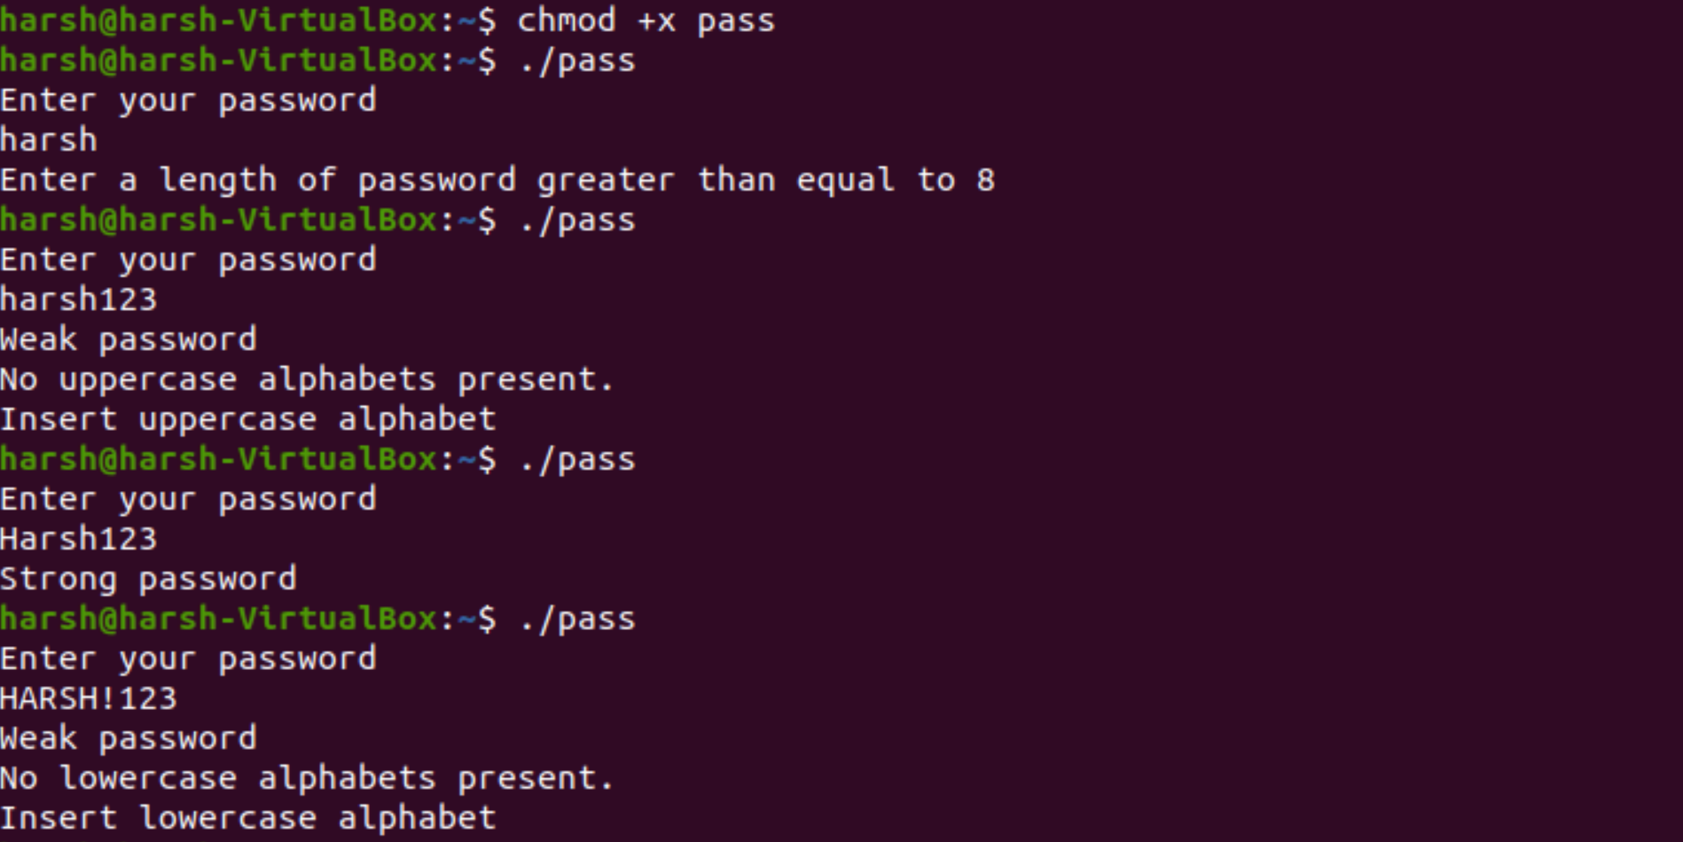

**__________________________________________**

**Question 8**

**How to check if the previous command was run successfully?**

**Solution -**

**Whenever a command runs, the return value of the command is stored in a specific bash variable.**

**Every command run in bash shell returns a value that’s stored in the bash variable “$?”. To get the value, run this command. $ echo $?**

**If a command succeeded successfully, the return value will be 0. If the return value is otherwise, then it didn’t run as it’s supposed to.**

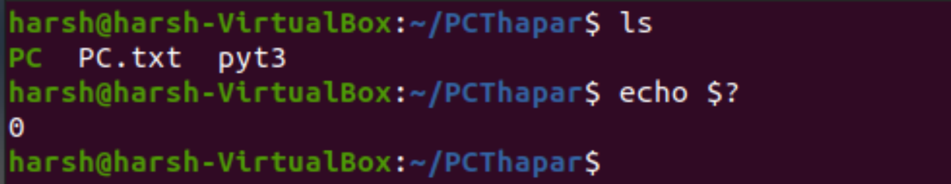

**__________________________________________**

**Question 9**

**How to get the last line from a file using just the terminal?**

**Solution -**

We can use the tail command to see just the last line of the file.

tail [ +-[number][lbcr] ] [file]

To see last line,

tail -1 [file]

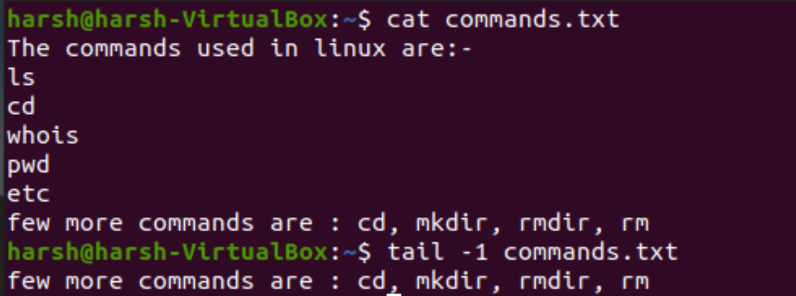

**__________________________________________**

**Question 10**

**How to get the first line from a file using just the terminal?**

**Solution -**

head command is used to view the first line.

head -n 1 filename.

We put 1 to view the first line.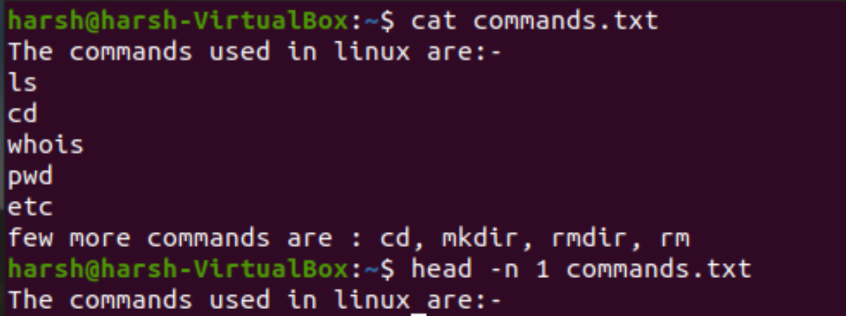

**__________________________________________**

**Question 11**

**How to print the first array element? How to print all array elements and their respective**

**indexes?**

**Solution -**

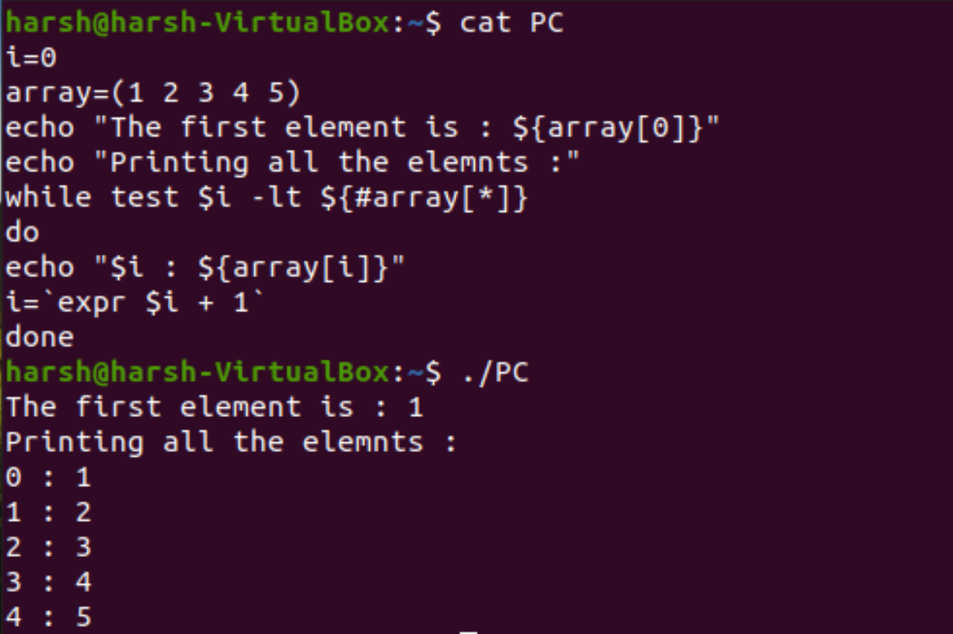

**__________________________________________**

**Question 12**

**Write a Shell Script that adds two numbers if provided as the command Line Argument and**

**if the two numbers are not entered throws an Error Message.**

**Solution -**

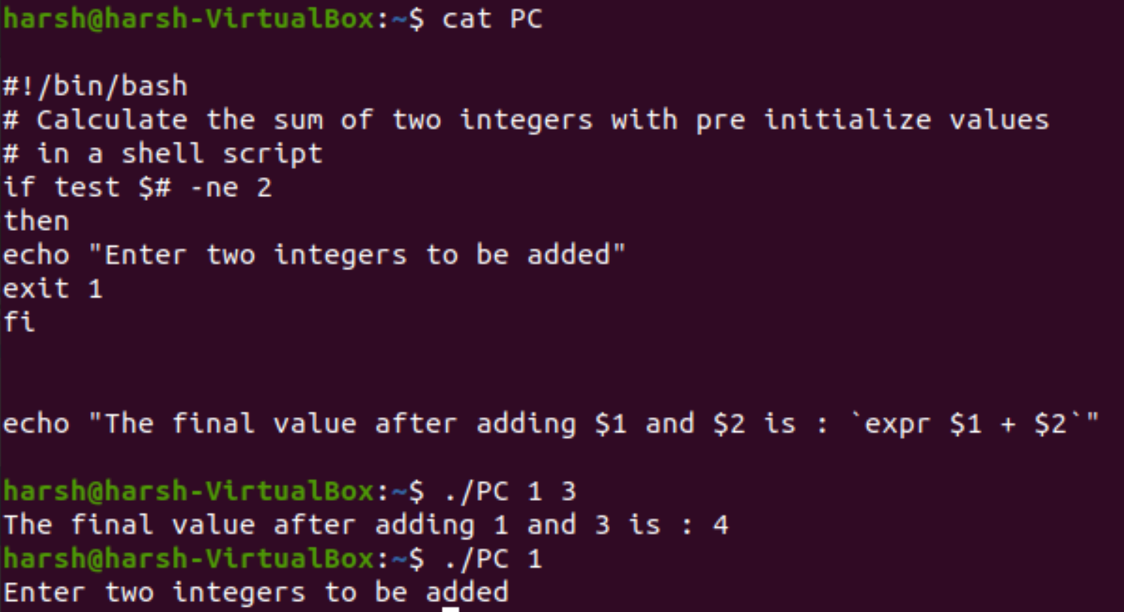

**__________________________________________**

**Question 13**

**For instance, we want to document the marks for a certain course. The total marks are 200**

**with 100 marks for Quizzes and 100 for assignments. We want to display the sum of assignments and quizzes while making sure the overall count does not exceed 200.**

**Solution -**

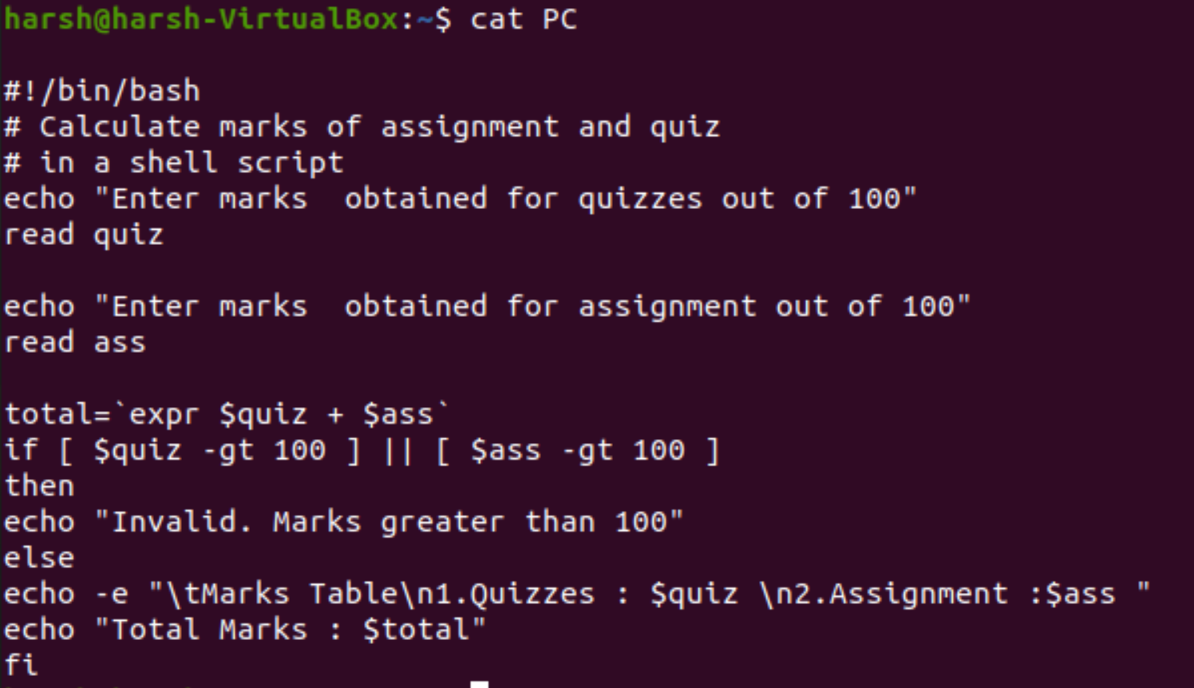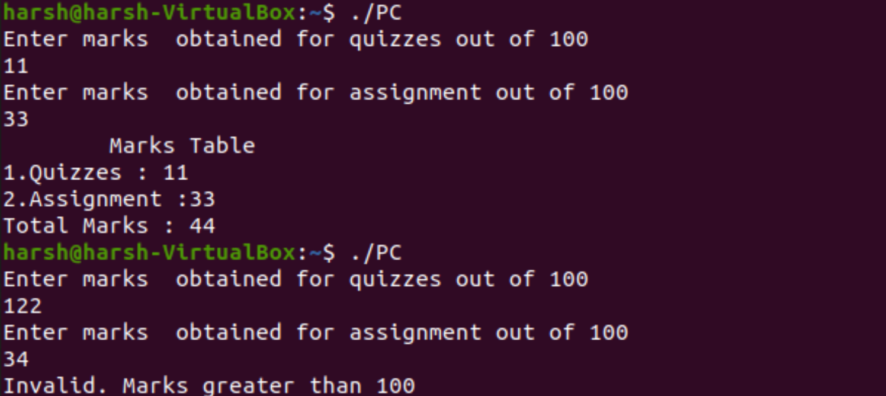

**__________________________________________**

**Question 14**

**Let’s take another example of a bank account program in which we want to have three**

**separate outputs for 3 different situations:**

**• The balance is less than zero**

**• The balance is zero**

**• The balance is above zero**

**For instance, in the following program, use the if, elif, else statements to display different**

**outputs in different scenarios**

**Solution -**



